Circuit Diagram
Environment Monitoring Device · CSPC-ICTU Server Infrastructure Monitoring System · October 2026

1. Overview
This is the wiring diagram of the environment monitoring device: an ESP32 on an expansion shield, connected to one DHT22, four MQ-2 smoke sensors, four IR transmitters, a buzzer, a 16-LED WS2812B strip, a DS3231 clock, a micro SD card module and a Wi-Fi setup button. The diagram is on the next page; the table below lists each connection.
The physical layout of the box is in the separate Hardware Schematic document.

2. Pin connections
Component | Pin | ESP32 pin | Notes
DHT22 | DATA | GPIO4 | VCC → 3.3 V (V row)
MQ-2 #1 | AO | GPIO34 | Through 10 kΩ / 20 kΩ divider · VCC → 5V
MQ-2 #2 | AO | GPIO35 | Through its own divider · VCC → 5V
MQ-2 #3 | AO | VP (GPIO36) | Through its own divider · VCC → 5V
MQ-2 #4 | AO | VN (GPIO39) | Through its own divider · VCC → 5V
IR TX #1 | S | GPIO25 | IR channel 1
IR TX #2 | S | GPIO33 | IR channel 2
IR TX #3 | S | GPIO32 | IR channel 3
IR TX #4 | S | GPIO15 | IR channel 4
Passive buzzer | + | GPIO26
WS2812B LED ×16 | DIN | GPIO27 | 5V → shield 5V pin
DS3231 RTC | SDA / SCL | GPIO21 / GPIO22 | I2C · VCC → 3.3 V
Micro SD card | CS / SCK / MISO / MOSI | GPIO5 / 18 / 19 / 23 | SPI · VCC → 5V
Wi-Fi portal button | one leg | GPIO13 | Other leg → GND (internal pull-up)

3. Power
- Supply: wall adapter → Mini UPS (5 V 2 A) → USB-C input on the ESP32 shield.
- 5 V: MQ-2 sensors, WS2812B strip and micro SD module, from the shield's 5V pin.
- 3.3 V: DHT22 and DS3231, from the shield's V rows (jumper set to 3.3 V).
- GND: common to every module.

4. Key notes
- Voltage dividers: each MQ-2 outputs up to 5 V, so AO → 10 kΩ → ESP32 pin, with 20 kΩ from that pin to GND, brings it to 3.3 V.
- VP and VN are input-only: fine for MQ-2 #3 and #4, but they cannot drive an IR transmitter.
- New MQ-2 channels are not read until enabled on the Environment page.
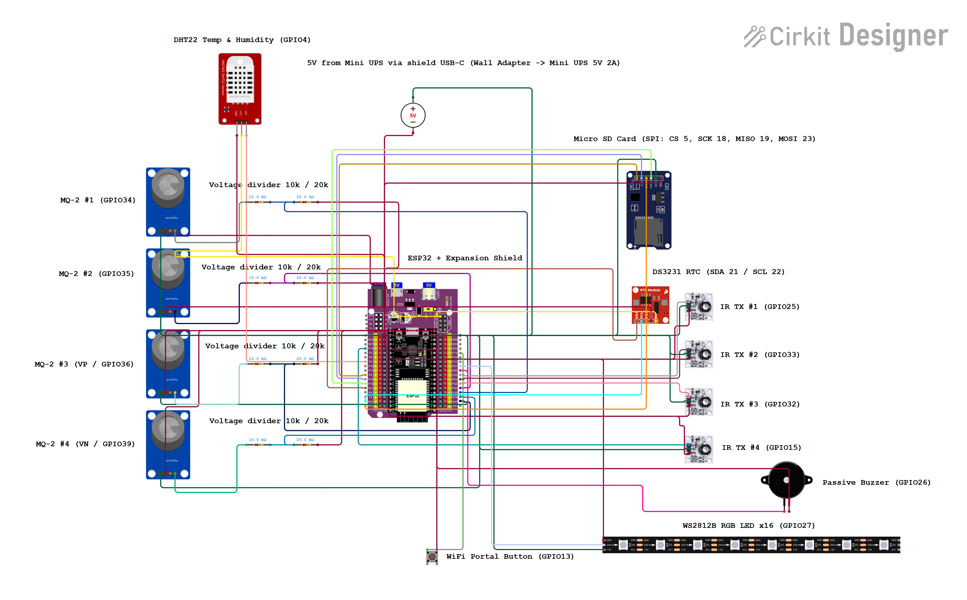
Figure 1. Circuit diagram of the environment monitoring device

